# **Innovation and Extra Functionality**

With reference to the python app (PythonApp.py) the following additions were made.

## Addition of extra menus

### Default Main Menu:

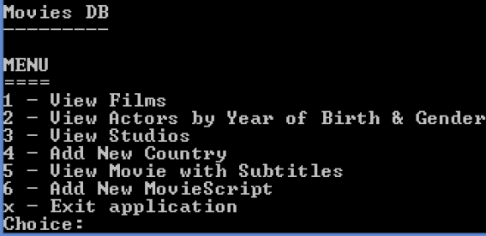

### Additional menus i.e., options *4, 6, 8, 10*

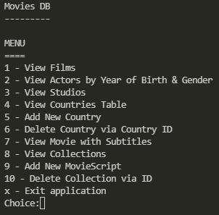

## Rational for the addition of extra menus:

The reasoning related to adding these additional menu options, was to promote a user-friendly experience and to further develop instances where ease of access could occur. The primary aim was to create a program that would allow all actions related to the databases to occur within the app itself and to remove the usage of additional programs i.e., additional instances of the command prompt would not need to be utilised in order to seek information related to the contents of the databases.

Menu options *4* and *8*, allow this behaviour to occur, in which information from the database can be read from within the python app. Further menus were then created to allow the user to add information to the database and remove information where they see fit i.e., menu options *6* and *10*.

## **Behaviour of menu options 4 and 6**

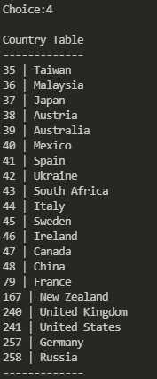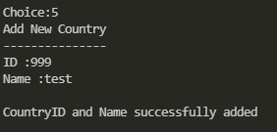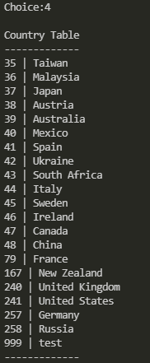

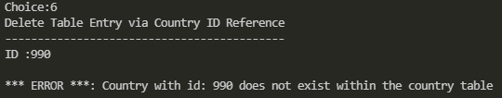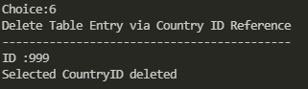

## **Behaviour of menu options 8 and 10**

